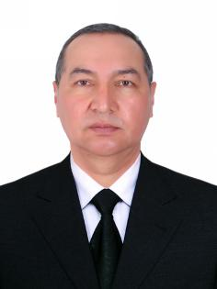
Resume – Farm Worker Application

Full name: Ikromov Shavkat Akramovich
Date of Birth: March 8,1972
Citizenship: Uzbekistan
Phone: +998(91) 614 16 36
Email:nnonamer47@gmail.com
Objective
Motivated and physically strong individual With over 30 years of leadership and Technical experience. Seeking a farm worker Position in Canada with visa sponsorship Ready to perform physically demanding Tasks and work in a team. Quick to learn and adept
Work Experience
2023 – 2024
Specialist, Construction Standards Laboratory
Andijan Regional State Architectural
Supervision Department
- Inspection and compliance with construction standards
2017 – 2023
Head of Communal Services Inspectorate Andijan Region
- Supervised public utility services across The region
2013 – 2017
Director of Driving School Khodjaabad
- Managed training process and Administration
1990 – 2012
Military Service ( Retired Colonel ) Republic of Uzbekistan
- Final position: Head of District Department of Defense, Andijan
Additional Farming Experience
- Worked on a family farm: planting, Harvesting, animal care
- Familiar with manual labor and rural Lifestyle

Education
- Bachelor’s Degree in Mechanical Engineering ( 1994 )
- Currently pursuing part -time degree in Civil Engineering ( 3rd year )
Languages
- Russian – Fluent
- English – Basic ( school level )
- German – Basic understanding
Driver’s License
- Categories B, C
- Gained practical experience in agricultural work through involvement in a family -owned farming business
- Skilled in operating tractors an other agricultural machinery

